Lung Tumor Detection using Pre-Trained Faster-RCNN

# **Abstract**

Pretrained networks are reliable tools to create and design machine learning application. Due to deep learning and computer vision developments, they are helping humans to make the work process easy specially in medical image analysis. In this task we propose a pre-trained faster-rcnn based object detector to detect lung cancer tumor coordinates in radiology images. Due to data shortage in medical field specially in radiology images, we used a public dataset placed in roboflow website to fine tune our deep learning model. The framework used in this task is pytorch.

# **Dataset**

Dataset used in this process, is a public dataset on roboflow website consist of 283 training image and 20 test images in size of 416 x 416 pixels. Due to unbalanced dataset distribution, we split the training dataset into 230 training images (80%) and 53 test images (20%). Dataset gathered in COCO format and contains a annotation.cococ.json file that point to image_id and bounding box of object in it.

# Method

We used the faster-RCNN pretrained network with resnet50 backbone implemented in torchvision package of pytorch. SGD optimizer with momentum 0.9 and learning rate 0.01 is used to optimize network during training process. Batch size of data in data loader is 10 for train loader and 5 for test loader. We trained network for 60 epochs.

Results

After 60 epochs of training whole training set, the model achieved precision score of 0.91 and recall score of 0.71. you can see the prediction result on an instance of test set in Fig1. However, we believe we could achieve much better results if there was a dataset with better quality and more instances provided by Longevity for this task. Dataset, and code is available in my GitHub page.

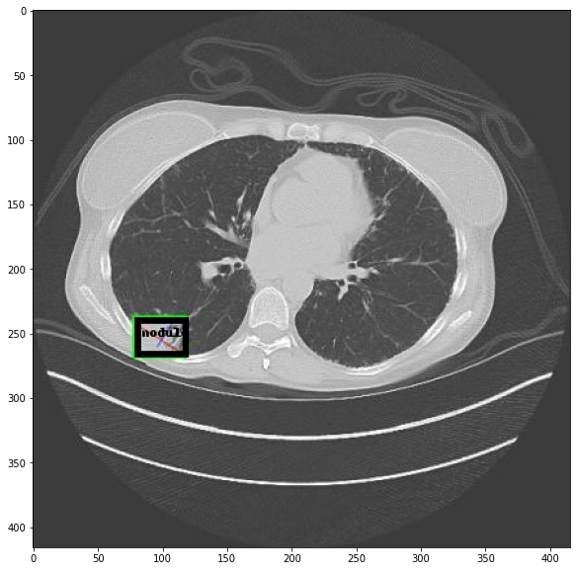

Figure 1, predicted bounding box (Black) and ground truth (Green)

# **References**

**Torchvision.com**

**Roboflow.com**

**Github.com/pr1266**